
Technical Audit Report
https://www.zavior.org/

Pingdom Tools
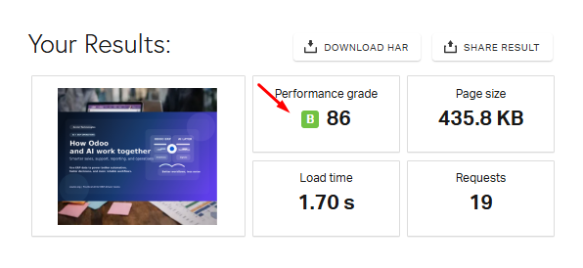
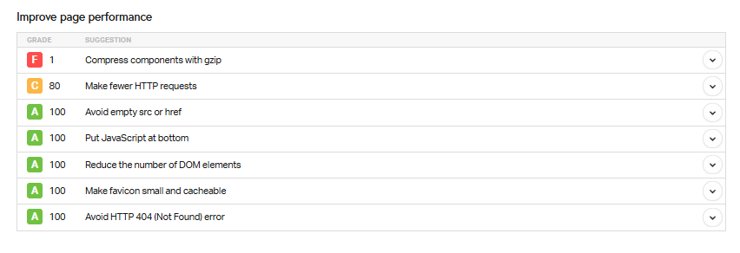

Google Page Speed Insights:
Mobile
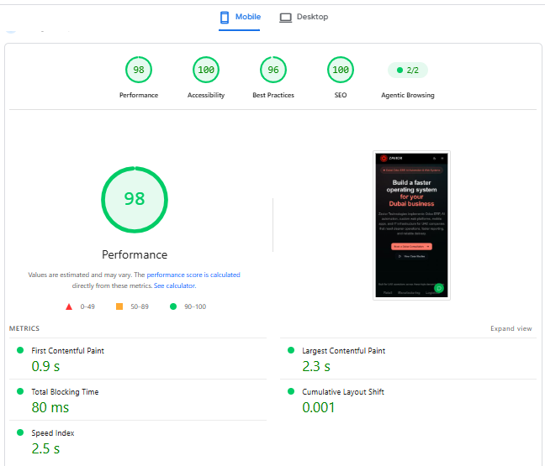
- As we can see, the Mobile Web Performance is good.

Desktop

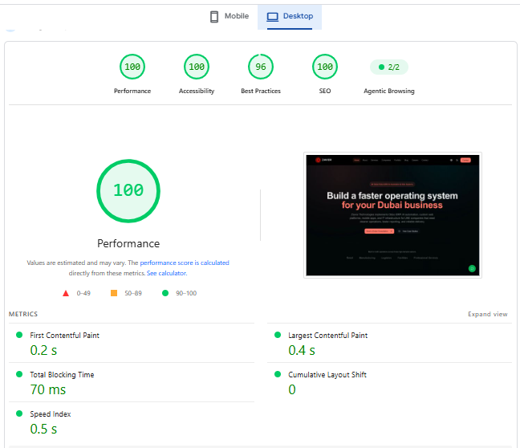
- The Desktop Web Performance is good.

Robots.txt Analysis
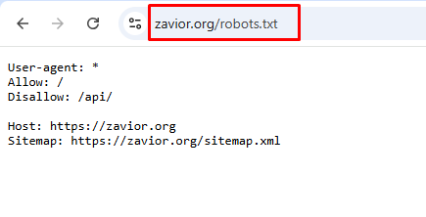
- The robots.txt file exists, but it is basic and needs to be optimized further.

Sitemap Analysis:
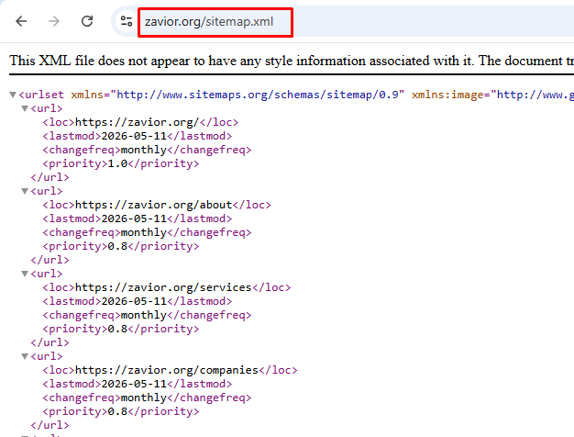
- The Sitemap file is present. And it’s looking good.
Mobile Friendly Test:

- The website is mobile-friendly.

Schema Check-up:
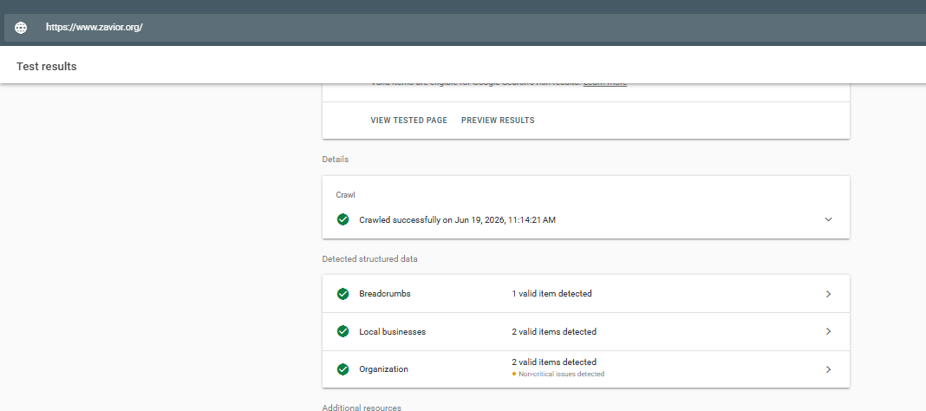
3 Types of schema found. Need to implement more schema.
Security Analysis
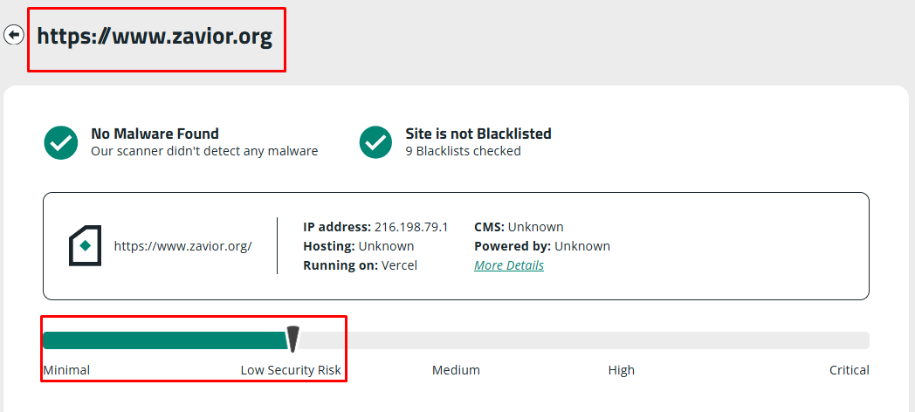

No malware found.

Thank You

